*Use the information in Chapter 39 (p. 824-827) to answer the following questions. You may also want to watch the following Bozeman podcasts:* [*Plant Control*](http://www.bozemanscience.com/science-videos/2012/5/6/plant-control.html?rq=auxin)*.*

**Concept 39.2: Hormones coordinate growth, development, and response to stimuli**

Explain what the experiment pictured below demonstrates about how the signal for phototropism is transmitted as well as the effect on the plant.

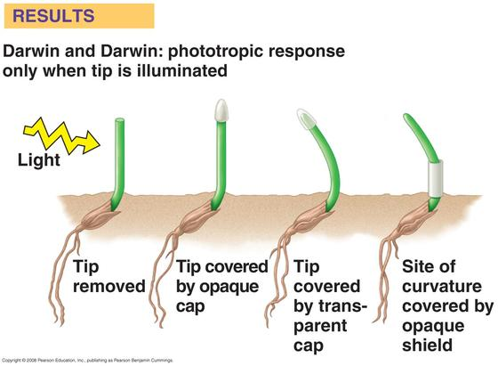

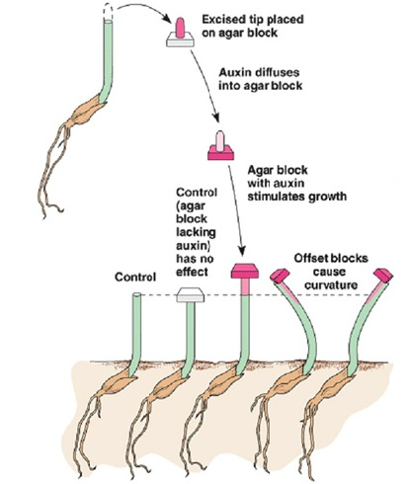Explain what the results of Went’s experiment tell us about how auxin causes a coleoptile to grow toward the light.

**Concept 39.4: Plants respond to a wide variety of stimuli other than light**

*Complete the chart to organize information about plant responses to stimuli.*

|  |  |  |
| --- | --- | --- |
| **Stimulus** | **Example of Stimulus** | **Plant Response** |
| Gravity |  |  |
| Mechanical Stimuli |  |  |